In this section, we aim to develop an optimal investment strategy for the associated funds. The investment horizon is set at five years, with $1,000,000 to be allocated among a selection of three stocks, namely Happy Tech, Risky Mining, and Kool Movies, as well as a five-year Guaranteed Investment Certificate (GIC). The primary objective is to achieve an expected annual return between 7% and 12% while minimizing portfolio volatility, assuming no management or transaction fees, no compounding, and constant expected returns, volatilities, and correlations over the analysis period. Short selling is prohibited, and the GIC capital cannot be accessed before the end of its five-year term.

To identify portfolios along the efficient frontier that meet the company’s return objective while balancing risk, a mean-variance optimization framework was applied. Inputs included the given expected returns, volatilities, and correlation structures for each asset, while the output is presented in Picture 1.

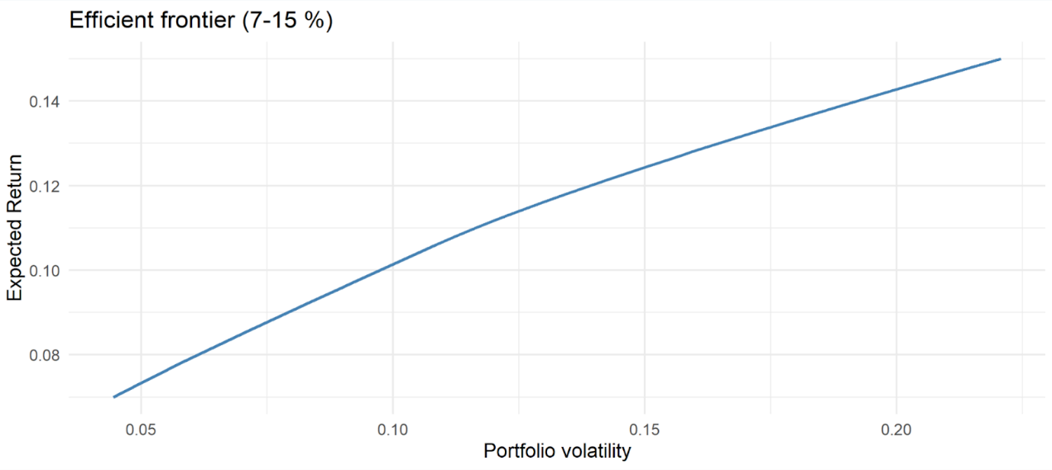

Picture 1: Efficient Frontier for Portfolio with Expected Returns between 7% and 15%.

This figure illustrates the relationship between expected return and portfolio volatility for the set of optimal portfolios. The efficient frontier takes the form of a nearly straight line, which is characteristic of a capital allocation line. The linearity arises because the GIC acts as a risk-free asset, allowing any risky portfolio on the frontier to be combined with the GIC to trace out a straight line between risk and return. This result demonstrates the trade-off faced by the company: higher returns are attainable, but only by taking on additional volatility.

From the efficient frontier, three portfolios are highlighted as examples because they represent distinct points of interest. The seven percent portfolio offers the lowest volatility while still meeting the company’s minimum return objective. The 8% portfolio represents a balanced allocation that fits comfortably within the target return range, while the 14% portfolio shows the end of a high-risk, high-return strategy that illustrates the cost of pursuing more aggressive targets. The composition of these portfolios is summarized in Table 1.

| Table 1: The Portfolios' Weights | | | | | | |
| --- | --- | --- | --- | --- | --- | --- |
| Portfolio | Expected Return (%) | Volatility (%) | Weight of Happy Tech (%) | Weight of Risky Mining (%) | Weight of Kool Movies (%) | Weight of GIC (%) |
| 1 | 8.00 | 6.13 | 33.45 | 18.15 | 48.40 | 0.00 |
| 2 | 14.00 | 19.22 | 25.00 | 75.00 | 0.00 | 0.00 |
| 3 | 7.00 | 4.45 | 20.50 | 12.59 | 66.91 | 0.00 |

The eight percent portfolio is characterized by a balanced mix, with heavy exposure to Kool Movies, which has the lowest volatility, moderate exposure to Happy Tech, and a smaller allocation to Risky Mining. Its volatility is just above six percent, reflecting a moderate but manageable level of risk. The fourteen percent portfolio, by contrast, is dominated by Risky Mining, which has both the highest return and the highest volatility, resulting in a portfolio volatility of over nineteen percent. This demonstrates how aggressively the optimizer must allocate to risky assets to push expected return to fourteen percent. Finally, the seven percent minimum volatility portfolio is dominated by Kool Movies, with minor positions in Happy Tech and Risky Mining. This allocation achieves the lowest volatility, approximately 4.45 percent, while still delivering the minimum acceptable return.

When considering recommendations, the seven percent portfolio emerges as the most prudent choice because it minimizes risk while meeting the company’s target return. Using a Monte Carlo simulation, the one-year Value at Risk at the 5% confidence level is estimated to be approximately 3,279 dollars. This means there is only a five percent chance that losses would exceed this amount in a given year, which is a reassuring measure of downside risk. For an insurance company that must prioritize stability to meet long-term policyholder claims, this allocation is well aligned with the firm’s needs.

However, one may also consider the fourteen percent portfolio as an alternative recommendation if the company has a greater tolerance for risk. While its volatility is much higher, it also provides significantly higher return potential. For a firm with strong operational cash flows and a willingness to accept fluctuations in investment performance, such a strategy could enhance overall profitability.

Two years into the horizon, market conditions are assumed to change, with updated returns and volatilities for the three stocks. Under the new parameters, the optimal allocation that still achieves at least seven percent return while minimizing volatility shifts even more heavily toward Kool Movies. The revised portfolio allocates over eighty percent to Kool Movies, with only small exposures to Happy Tech and Risky Mining, resulting in an expected return of approximately 7.01% and a volatility of just 3.56%. Given that the GIC remains illiquid until maturity, this reinvestment emphasizes the adaptability of the strategy and reinforces the importance of revisiting portfolio allocations when market conditions evolve.

In conclusion, the results of this analysis clearly demonstrate that the company has two viable paths, depending on its risk appetite. The seven percent minimum volatility portfolio is the most appropriate recommendation for Awesome Insurance Company, while supporting the company’s long-term responsibility to its policyholders by ensuring stable investment income. At the same time, it is important to recognize that we may seek to pursue higher returns to strengthen profitability. In that case, the fourteen percent portfolio can serve as an alternative option, provided the company is prepared to accept significantly greater volatility.